CIS 344

Arnab Das

5/23/24

Final Project Report

Overall, for this project, I have to say it has been difficult to actually complete error free. Firstly, I had issues with connecting python with MySQL. It took me about an hour or two trying to sort things out. When I first downloaded python, I guess I must have not pressed the right buttons because when I tried connecting it to MySQL, it did not work. I tried to rewatch the videos to figure out what I did wrong, I typed in a command on my computer to make it work but still nothing. I then had the idea to uninstall python and then reinstall it from the Microsoft store. That did not work either and I ended up uninstalling it again. Now I reinstalled it again fresh from the python website, I installed the latest version and finally it had started working. Finally, I can start coding on python and MySQL now.

Everyone was doing well so far; I followed the directions that the professor gave us and did everything in order. Then I ran into another issue, I kept getting a duplicate error. So, this error set me back quite a bit because I did not understand the error properly because it kept saying duplicate error even though there was no duplicates. For the customer information, it kept saying I kept duplicating the customer id multiple times which is simply not true. I had honestly though I was going insane. After playing around with the code and structure, I had finally solved the issue, I needed to insert the customer data a bit earlier in the code rather than all the way down below. After this, the issue had finally resolved itself, if I hadn’t resolved this issue, I would have quit the project altogether.

Then I moved on to the python code and added new methods. Alongside this, I wanted to attempt the bonus points things as well. I had run into another hiccup here as well. I had implemented a nice-looking website on the localhost and then I am not sure what happened, but all of the columns showed data from other columns, everything was mismatched. I had spent the majority of the morning trying to fix this issue as I am not sure if it was because of the code in MySQL or the code in python. Changing something in MySQL seemed nonresponsive where even if I changed something major, it showed me the results of my previous attempt the website where it was looking good. Changing something on the python database also proved to be difficult as changing all trivial things had the potential to break the whole website, making the website unable to load. I had tried to add in new functions and code in the server and database for the reservations and although it works, it doesn’t save. You can enter all of the information to make a reservation but as soon as you click enter, you just see a blank screen. This project has been difficult, and I did not want to break the website any further, so I had left it without changing too much.

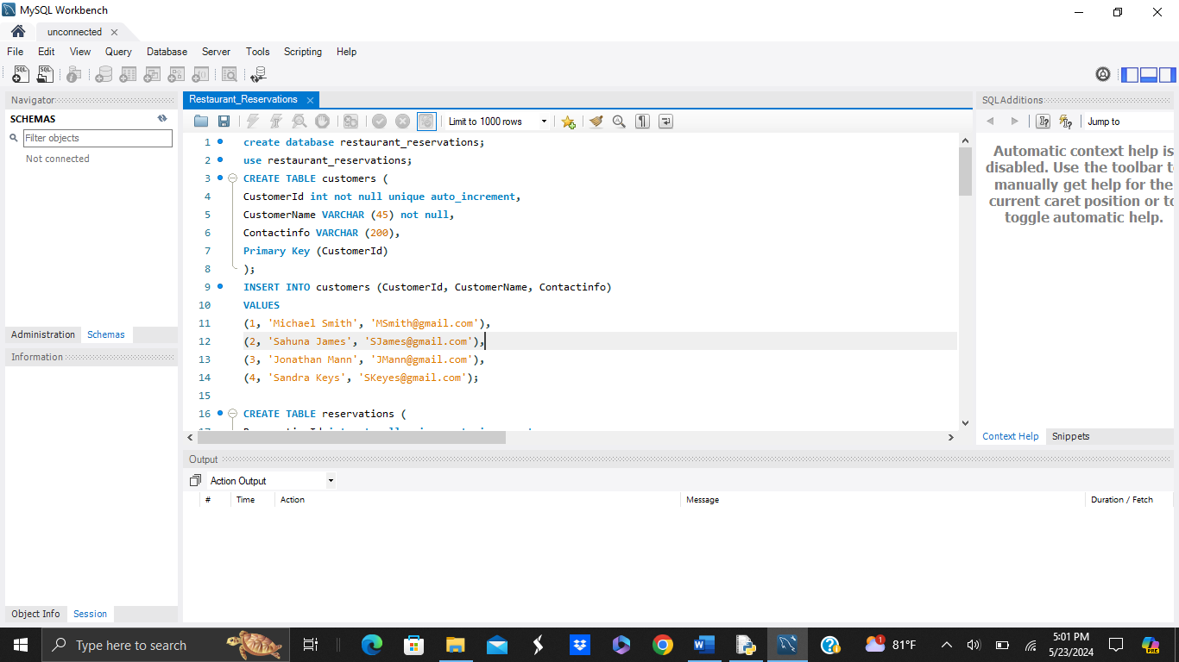

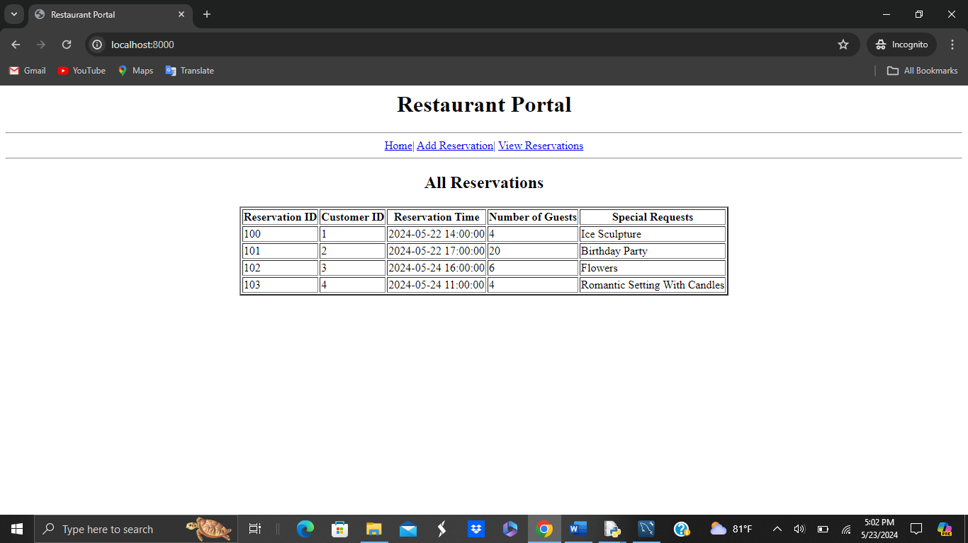

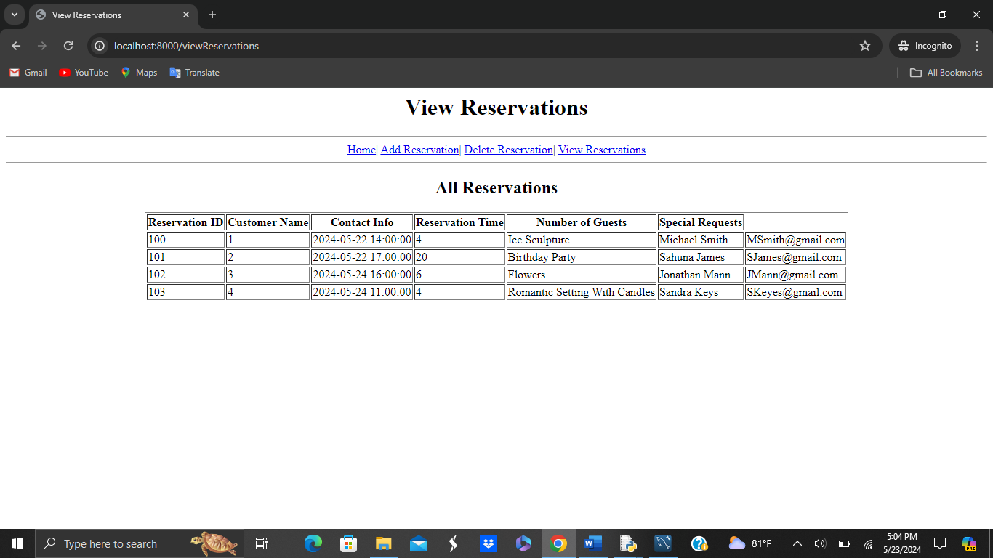

Here you can see that there is still errors.

https://github.com/Arnab442/CIS-344-Final-Project.git